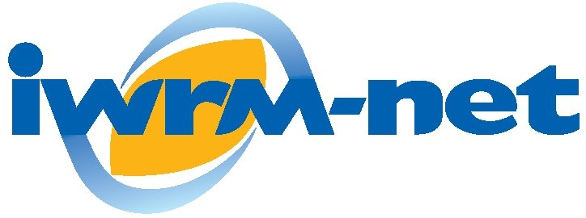

Integrated Water Resource Management
Network

“Improving Cooperation in Fresh Water Research across Europe”

Report on the
Final IWRM-NET International in Brussels
1-3 December 2010

Document Dissemination Level
PU | Public | PU
PP | Restricted to other programme participants (including the Commission Services)
RE | Restricted to a group specified by the consortium (including the Commission Services)
CO | Confidential, only for members of the consortium (including the Commission Services)

Report Number D 6.4.2

Revision Number Draft

Co-ordinator: OIEAU

Project Contract No: ERAC-CT-2005-026025

Project website: www.iwrm-net.net
Date Dec 2010

Deliverable Number: D 6.4

Due date for deliverable: Dec 10

Actual submission date: Dec10

Task Leader Environment Agency UK

Document Information

Title | Final IWRM-NET International in Brussels  1-3 December 2010
Lead Author | Peter Allen-Williams
Contributors
Distribution | Public – via website
Document Reference

Document History

Date | Revision | Prepared by | Organisation | Approved by | Notes
31/12/10 | 1 | PAW | EA,UK |  | Draft

Acknowledgement

The work described in this publication was supported by the European Community’s Sixth Framework Programme through grant to the budget of the Co-ordination Action IWRM-NET-CA, Contract ERAC-CT-2005-026025

Disclaimer

This document reflects only the authors’ views and not those of the European Community. This work may rely on data from sources external to the IWRM-NET project. Members of the project do not accept liability for loss or damage suffered by any third party as a result of errors or inaccuracies in such data. The information in this document is provided “as is” and no guarantee or warranty is given that the information is fit for any particular purpose. The user thereof uses the information at its sole risk and neither the European Community nor any member of the IWRM-NET project is liable for any use that may be made of the information.

Overview

Over 100 delegates from16 European countries met to share and work on ways to ideas and processes to improve co-operation in the Science Policy Interface in IWRM and develop the research agenda. The meeting was very successful and the following key-points were noted.

Conference contributions
During the project, methods of communication became increasingly “electronic” as opposed to “paper-based”. IWRM-Net experimented with some of these methods which are speedier and impose less of a burden on our planet’s dwindling resources. During the project, it became increasingly obvious that project participants prefer electronic to paper-based communication. Consequently, publications of “Hard copies” as called for in the DoW were minimised.
An executive decision was also taken early in the planning of the Final International Event to minimise the use of paper wherever possible. The implications of this decision were:
- delegates were supplied with a memory stick containing IWRM-net outputs as part of their delegate pack
- all presentations were uploaded to the European Water Community (EWC) website during the conference
- the entire conference was recorded onto both a high quality sound track and by video camera.
- edited outputs from the conference will available from the IWRM-Net website

Some of the key points made:
- Science Policy Interface

- IWRM research in Europe

- Future of IWRM-NET:

Contents

Document Information ii
Document History ii
Acknowledgement ii
Disclaimer ii
Overview iii
Contents iv

Introduction ………………………………………………………………………….5

Appendix I – Final Programme……………………………………………………...

Programme 11
Day 1 – Improving the European Water Research Landscape 11
Day 2 – The Contribution of IWRM.Net to the European Research Area for Water 12
Day 3 – Training workshops 13
DAY 1
Welcome address and introduction 14
Session 1: European Water Research Needs and Challenges 14
Keynote presentation 1: The research demands of the Water Framework Directive (WFD) Common Implementation Strategy 2010 – 2012. 14
Keynote Presentation 2: Implementing the WFD – The Research Challenges 14
Keynote Presentation 3: Status and perspectives for the European Research Area for Water and its link with innovation policies 14
Session 2 – Research Coordination 14
Keynote presentation 1: The Water Joint Programming Initiative (JPI) 14
Keynote presentation 2: European Water Innovation 15
Keynote presentation 3: Networking beyond IWRM-Net 15
Session 3: Plenary Discussion (with the panel of all 6 speakers) 15
DAY 2
Session 1: overview of IWRM-Net achievements and future plans 15
Presentation 1: The trans-national water research agenda 15
Short presentations of completed IWRM-Net funded projects 15
Keynote presentation 2: Introduction to the Scientific Coordination Project 16
Short presentations of newly started IWRM-Net funded projects 16
Keynote presentation 3: Sustainability Plan for IWRM-net 17
Networking Lunch: View the IWRM-Net Research Project posters and meet the researchers & informal training session: 18
Session 2: Science to Support Water Policy and Management 18
Keynote presentation 1: Strengthening the Water System Science and Environment Policy Interface: barriers, efforts and solutions 18
Keynote presentation 2: A research funders perspective of operating though IWRM-Net 18
Keynote presentation 3: A research “end-user’s” perspective of IWRM research 18
Key note presentation 4: CIS –SPI initiative 19
Session 3 Knowledge exchange - Catalysing the human network 19
DAY 3
Presentation 1: KNAC 20
presentation 2: I-Five 20

Appendix I – Final Programme

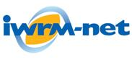
Final Conference

Improving Cooperation in Fresh Water Research across Europe
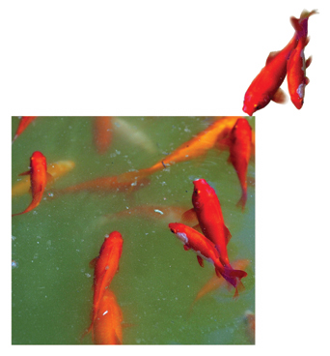
Programme

Brussels
1 – 3 December
2010

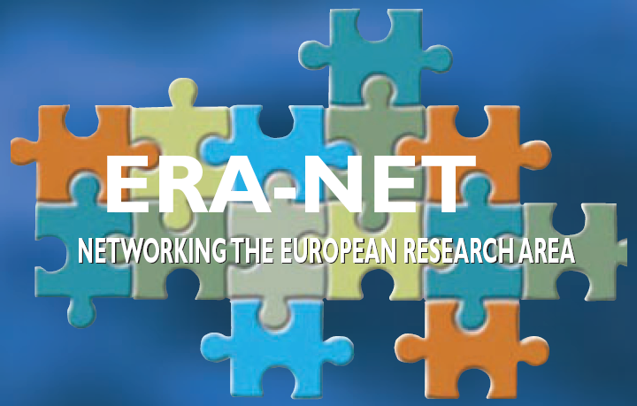
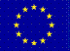

IWRM-Net ERA-Net has mainly been dedicated to bridge the gap among national research programmes dealing with Integrated Water Resource Management. Through its final event “Improving Cooperation in Fresh Water Research across Europe”, IWRM-Net partners would like to share their experience acquired over the five years of the projects and nourish wider reflection at the European and trans-national levels.
Target audience
The conference is addressed to European Water Policy Makers, National Users and Research Programme Managers and researchers
Aims of the conference
  - To improve the coherence and coordination of water research in Europe
  - To meet the needs of the Water Framework Directive
  - To demonstrate the contribution of IWRM-Net to the European Research Area for Water
Expected outcomes and conference organisation

Day 1: Improving the European Water Research Landscape
European water research needs and challenges
Research coordination
Plenary session
Day 3: Training workshops in Hydro-morphology and Governance

KNAC project
I-Five Project
Identify and highlight issues that need to be addressed to increase the coherence of the water area of the European Research Area
Turning knowledge gaps into high quality scientific research and then into operational practice
Support scientific results dissemination
Allow networking
Day 2: The Contribution of IWRM.Net to the European Research Area for Water
Overview of IWRM-Net achievements and future plans
Science to Support Water Policy and Management
Knowledge Exchange Catalysing the Human Network

Content
Target audience 2
Aims of the conference 2
Expected outcomes and conference organisation 2
Content 3
The European Water Community 4
Programme 6
Day 1 – Improving the European Water Research Landscape 6
Day 2 – The Contribution of IWRM.Net to the European Research Area for Water 7
Day 3 – Training workshops 8
DAY 1
Welcome address and introduction 9
Session 1: European Water Research Needs and Challenges 9
Keynote presentation 1: The research demands of the Water Framework Directive (WFD) Common Implementation Strategy 2010 – 2012. 9
Keynote Presentation 2: Implementing the WFD – The Research Challenges 9
Keynote Presentation 3: Status and perspectives for the European Research Area for Water and its link with innovation policies 9
Session 2 – Research Coordination 9
Keynote presentation 1: The Water Joint Programming Initiative (JPI) 10
Keynote presentation 2: European Water Innovation 10
Keynote presentation 3: Networking beyond IWRM-Net 10
Session 3: Plenary Discussion (with the panel of all 6 speakers) 10
DAY 2
Session 1: overview of IWRM-Net achievements and future plans 10
Presentation 1: The trans-national water research agenda 11
Short presentations of completed IWRM-Net funded projects 11
Keynote presentation 2: Introduction to the Scientific Coordination Project 11
Short presentations of newly started IWRM-Net funded projects 11
Keynote presentation 3: Sustainability Plan for IWRM-net 13
Networking Lunch: View the IWRM-Net Research Project posters and meet the researchers & informal training session: 13
Session 2: Science to Support Water Policy and Management 14
Keynote presentation 1: Strengthening the Water System Science and Environment Policy Interface: barriers, efforts and solutions 14
Keynote presentation 2: A research funders perspective of operating though IWRM-Net 14
Keynote presentation 3: A research “end-user’s” perspective of IWRM research 14
Key note presentation 4: CIS –SPI initiative 15
Session 3 Knowledge exchange - Catalysing the human network 15
DAY 3
Presentation 1: KNAC 16
presentation 2: I-Five 16
Steering committee 16
Registration 16
For more information on the conference 17
Venue 17

The European Water Community

The European Water Community, What is it? :
To support the collaboration, transfer of knowledge and exchanges of ideas, IWRM-net has set up an online community named European Water Community (EWC - www.europeanwatercommunity.eu). EWC is hosted by Tweegg, a virtual platform (Web 2.0 the ‘participatory Web’) designed as a collaborative and social networking tool.
IWRM-net and the International Office of Water have been testing the software as a pilot to bridge the gap between science and policy, to encourage links between research and research programmes and especially to join up the scientists, the policy makers and the water managers. EWC stays widely open to all water stakeholders.
As a means of testing the software over a short period of time we are making the platform available to the delegates of the conference to help comments and communication with the speakers and each other before, during and after the conference.
Before the final conference we have made information available on the platform such as the final agenda, list of delegates, different contributions like ‘Changing Climate’, ‘Wetlands’ or ‘Science Policy Interface and IWRM-Net’.
Here is one example of screen showing the page about the idea on ‘Science Policy Interface and IWRM-Net’ always in progress:
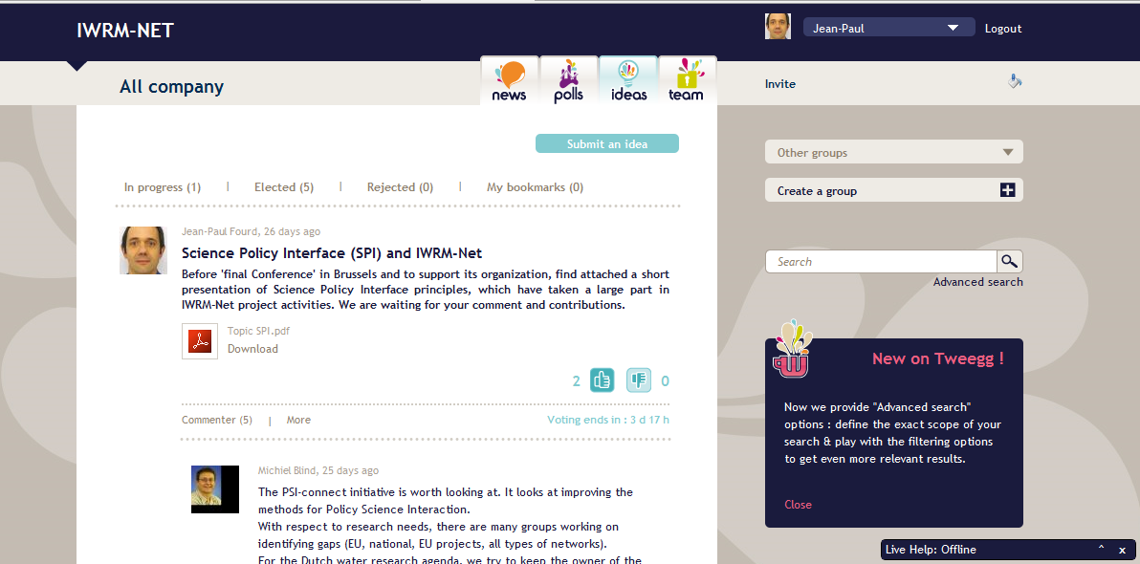

You are requested to become a member of EWC before coming to the meeting in Brussels, because during the plenary discussions, the platform will be used to facilitate the exchanges.
That’s why you may find now on EWC the specific group ‘Final Conference LIVE’. In this group dedicated tags or IDEAS will link to documents concerned: more you will be able to post comments or ask questions concomitantly on each presentation you hear.
This way will help spontaneity to the discussion and it will give the possibility to answer to your questions quickly.
If the response is not given during the conference then there will be opportunity to receive a response after the presentation when there is more time available and perhaps a new business relationship can be developed over time.
In the final session we are also going to use the validation of research needs as a process to be tested within the EWC. There is the facility to vote on ideas and so at the end of day 2 in the final session, you the delegates will be requested to go online and provide your views and votes on what are the priorities for the future in terms of water research.
YOU HAVE BEEN SENT AN INVITATION
If you cannot find this then contact Jean-paul Ford who will re-register you and you can then follow the procedure below to enter EWC
- go to www.europeanwatercommunity.eu ;
- enter your professional email.
- Then you will receive an email with a link to complete an identification form.
- Do it before coming to Brussels and begin to surf on EWC. We are looking forward to your comments.
After the conference, the information will remain available for further discussion. What we hope is that with future projects designed to keep testing the software there shall be available a virtual network designed specifically for facilitating an European network for water research that shares information, supports collaboration and disseminates results.
If you have any problems you can contact Jean-Paul Fourd jp.fourd@oieau.fr
Programme

Day 1 – Improving the European Water Research Landscape

Particularly for EU Water Policy Makers and national Research Programme Managers
Wednesday 1 December 2010
Improving the European Water Research Landscape
12:00 | Registration
13:00 | Welcome and opening  Ian Barker, Environment Agency, Head of Water, Uk
Session 1: European water research needs and challenges
Chairperson: Jean-François Donzier, OIEau General Manager & INBO Permanent Technical Secretariat, Fr
The research demands of the Water Framework Directive (WFD) Common Implementation Strategy 2010 – 2012
Peter Gammeltoft, DG Environment, EC
European Water Research Challenges
Patrick Flammarion, ONEMA, Fr
Status and perspectives for the European Research Area for Water and its link with innovation policies
Andrea Tilche, DG RTD, European Commission
 | Refreshment Break
15:15 | Session 2– Research coordination  The Water Joint Programming Initiative  Enrique Playan, MICINN
European Water Innovation
Céline Hervé-Bazin, WSSTP
Networking beyond IWRM-Net
Stephen Midgley, IWRM-Net, OIEau, Fr
Research into action – a practical example
Jason Alexandra, Former Director, Land Water Australia.
16:45 | Session 3 - Plenary Discussion  Moderated by Tony Juniper, UK
17:30 | Close day 1
19:30 | Social dinner

This first half day is for a high level audience and aims to provoke a lively discussion, facilitated by Tony Juniper. It has three parts – the first session surveys the current scene, the second looks at future initiatives and the third is a plenary discussion between an audience informed by the first two sessions and the panel. The aim is to identify and highlight issues that need to be addressed to increase the coherence of the water area of the European Research Area.

Day 2 – The Contribution of IWRM.Net to the European Research Area for Water

Particularly for Researchers and Research programme managers

The second day focuses on work by IWRM-Net on research and the science policy interface. It will present achievements of the IWRM-net project itself and then look at how the partners and other organisations can improve the process of turning knowledge gaps into high quality scientific research and then into operational practice.
Thursday -
Afternoon

14:00 | Session 2– Science to Support Water Policy and Management  Chair person: Philippe Quevauviller, DG Research, EC
Strengthening the Water System Science and Environment Policy Interface: barriers, efforts and solutions
Karen Fabbri, DG Research, EC
A research funders perspective of operating though IWRM-Net
Marie Cugny-Seguin, MEEDDM, Fr
A research “end-user’s” perspective of IWRM research
Teodoro Estrela, Jucar Basin Authority, SP
CIS –SPI initiative
Marie-Perrine Durot, ONEMA, Fr
15:15 | Refreshment Break
15:35 | Session 3: Knowledge Exchange – Catalysing the Human Network  Michiel Blind, Deltares, Netherlands & Stephen Midgley, OIEau, France.  (see page 15 for details)
16:45 | Concluding Comments  Gilles Neveu, International Office for Water
17:00 | Close

Thursday 2 December 2010
Improving the European Water Research Landscape
09:00 | Welcome and opening  Gilles Neveu, IWRM-Net, OIEau, Fr
09:15 | Session 1 Overview of IWRM-Net achievements and future plans  The trans-national water research agenda  Stephen Midgley, OIEau, FR & Marie Cugny-Seguin, MEEDET, Fr
09:45 | Short presentations of completed IWRM-Net funded projects  - I-Five  - KNAC  - RIPFLOW  - FORECASTER
10:15 | Introduction to the Scientific Coordination Project  Stephen Midgley, OIEau, Fr
10:25 | Short presentations of newly started IWRM-Net funded projects  - ESAWADI  - WATER2ADAPT  - Water Cap & Trade  - Climate Change  - ICARUS  - IMPACT
11:10 | Refreshment Break
11:30 | Sustainability Plan for IWRM-net,  Hanna Arola, SYKE, Fi
11:45 | Plenary Discussion: How to continue coordination of research on the theme of water management?
12:30 | Networking Lunch  View the IWRM-Net Research Project posters and meet the researchers

Day 3 – Training workshops

Particularly for Researchers and water managers
Friday 3 December 2010
Training workshops Water Governance
09:00 | Welcome and introduction  Stephen Midgley, IWRM-net coordinator, OIEau
09:15 | Presentation of KNAC outputs  Addressing losses in translation in river restoration
09:45 | Presentation of I-FIVE outputs  Innovative Instruments and Institutions in Implementing the Water Framework Directive
10:15 | Refreshment Break
10:45 | Parallel workshops  Room 1 – KNAC  Room 2 – i-FIVE
12:45 | Close

The third day provides an opportunity to learn in more detail about the research funded by IWRM-net partners. The first joint call was on the subjects of hydro-morphology and water governance. Two projects will run training sessions based on the research they have undertaken.
The aim is to provide another opportunity at the European level to disseminate the knowledge created during the research projects and provide a wider audience with an opportunity to comment on the findings. This is your chance to learn and share your experiences in detail with the researchers

Detailed agenda and abstracts
DAY ONE: Wednesday 1 December
Improving the European Water Research Landscape

Welcome address and introduction
Ian Barker, Environment Agency, Head of Water, UK

Session 1: European Water Research Needs and Challenges
Chairperson: Jean-François Donzier, OIEau
This session will provide delegates with an understanding of the evolving European research agenda for Integrated Water Resource Management. Research needs will be identified from two perspectives – those of a WFD policy user – river basin manager or similar - and an internationally known researcher. Finally a DG Research speaker will give an overview of recent developments in the European Research Area, particularly as it relates to water.

Keynote presentation 1: The research demands of the Water Framework Directive (WFD) Common Implementation Strategy 2010 – 2012.
Peter Gammeltoft, DG Environment, European Commission
This presentation will highlight the demand on research for European Policy and the knowledge gaps that exist in the language of policy makers in Europe. The implementation of the WFD has been a significant driver for water research across Europe over the last 10 years. It remains a significant driver and continues to aid the collaboration and integration across Europe, of which the Common Implementation Strategy is a central tool. The working groups continue to function and the research of IWRM-net will aim to provide resources to support this work.

Keynote Presentation 2: Implementing the WFD – The Research Challenges
Patrick Flammarion, ONEMA, FR
The National Agency for water and the aquatic environment in France is a relatively new organisation with a big responsibility for the integrated management of water resources. It provides support to the regional water agencies and has to manage and disseminate the latest research and knowledge across France. This presentation will highlight the challenges that lay ahead for ONEMA in the management and delivery of research to support this role and the influence national agencies must have on the development of European Research Needs.

Keynote Presentation 3: Status and perspectives for the European Research Area for Water and its link with innovation policies
Andrea Tilche, DG RTD, European Commission
DG Research are the pioneers of the European Research Area. From the heart of the policy making machine we will hear about the principles behind the policy, how it’s implemented and the gains made in the coordination of research across Europe. Focusing on the water it will also highlight the innovation emerging from Europe and how at a strategic level the policies support the growth of Europe and better implementation of good water management

Session 2 – Research Coordination
The future of EU research for integrated water resource management, and successful development of the Water ERA, will be dependent upon the interaction between the key coordination actions in this area – the Joint Programming Initiative, the water industry technology platform, WSSTP and the future IWRM-Net Network. This session will promote understanding of the interaction between them.

Keynote presentation 1: The Water Joint Programming Initiative (JPI)
Enrique Playan, MICINN
Water Challenges for a Changing World; In 2008, the European Commission presented a new policy: „Towards joint programming in research‟ with the meaningful subtitle “Working together to tackle common challenges more effectively‟. They challenged countries to develop initiatives on joint programming with the purpose of increasing the efficiency and impact of national public funding in strategic areas. The challenges for water management cannot be fully addressed by any individual Member State alone. The Water JPI provides an opportunity for economies of scale, larger critical mass of resources and for more cross-border programme collaboration, to widen up the scope of European proposals, and increase the impact of research by exploiting the multiplying effect of trans-national and multi-disciplinary cooperation in Europe and beyond.

Keynote presentation 2: European Water Innovation
Cèline Hervé-Bazin, WSSTP
“WssTP as the European Water Technology Platform acts as a key player to promote research and technology in the water sector. It delivers a common vision for water innovation focusing on technology developments and need in a short and long term agenda. One of the missions of the platform is to shape the future priorities for research and innovation; it includes promoting water in the political agenda in particular after the launch of the Innovation Union and boosting the allocation of RTD budget of the European Commission from fundamental research to bottom-up initiatives.”

Keynote presentation 3: Networking beyond IWRM-Net
Stephen Midgley, IWRM-Net project officer OIEau
Focused at the strategic level, this presentation will highlight the sustainability plan produced by IWRM-net partners. The challenge facing the partners now is to maintain the contacts and network developed throughout the EU project, once the EU funds disappear. The sustainability plan considered a number of options available, using Web 2.0 tools or using a subscription fee and small secretariat. It will also discuss the tasks and information required to develop good collaboration in water research funding.

Session 3: Plenary Discussion (with the panel of all 6 speakers)
Tony Juniper is a campaigner, writer, sustainability adviser and a well-known British environmentalist. For more than 25 years he has worked for change toward a more sustainable society at local, national and international levels. From providing ecology and conservation experiences for primary school children, to making the case for new recycling laws, to orchestrating international campaigns for action on rainforests and climate change, his work has sought change at many levels.

DAY TWO: Thursday 2 December
The Contribution of IWRM.Net to the European Research Area for Water

Welcome address and introduction
Gilles Neveu - International Office for Water, France

Session 1: overview of IWRM-Net achievements and future plans
Chairperson: Michiel Blind, Deltares.
This session will provide delegates with an appreciation of the contribution of the IWRM-Net ERANET to the European research area for water. It will showcase the jointly funded research projects – both those completed and those just starting. This will lead on to a more detailed discussion of IWRM-Net members’ aspirations for future collaboration

Presentation 1: The trans-national water research agenda
Stephen Midgley, International Office for Water, Fr, Marie Cugny-Seguin, MEEDM, Fr
The Scotland and Northern Ireland Forum for Environmental Research took on the task of managing the short term research needs, while the Ministry for Ecology, Energy, Sustainable Development and the Sea, France investigated the long term needs. After producing the deliverables and launching 2 joint calls the French Ministry has taken the lead with partners including ONEMA, ADERA-ECOBAG, AQUAPOLE and SNIFFER in combining the two work streams to produce a document that guides the future collaborations. It aims to set out a classification system for water knowledge and provide a mechanism to support discussions between research funders.

Short presentations of completed IWRM-Net funded projects
  - I-Five
  - KNAC
  - RIPFLOW
  - FORECASTER

Keynote presentation 2: Introduction to the Scientific Coordination Project
Stephen Midgley, International Office for Water, France
The IWRM-net Scientific Coordination Project aims to provide the continuity of research projects’ follow up funded by IWRM-net 1st and 2nd calls, both on the administrative and technical sides. The ambition is to embed the IWRM-net research within the scope of the European Research Area. The challenges that lay ahead are the interface between the projects, the core group and the partners, the need to create synergies between the projects, the partner programmes and other networks and the support to disseminate the knowledge produced to the core funders, the wider scientific community and the water managers and policy makers.

Short presentations of newly started IWRM-Net funded projects
  - ESAWADI,
Using Ecosystem Services Approach in the Water Directive Implementation. The starting point is that economics has an important role in the WFD process (information for water management and water policy decision making) and there are economic requirements in the WFD which provide a challenge for the water administrations. The aim is to analyze and provide advice on the potential usefulness of the Ecosystem Services Approach (ESA) to support the implementation of the WFD economic requirements. The policy relevance focuses on the methodological links of the ESA to the WFD, but also on the participation and communication value of the ESA for WFD-implementation. There are three case studies - the Dordogne in France, the Ems in Germany and the Mondego in Portugal.

  - WATER2ADAPT
The alteration of rainfall patter (form, intensity and timing of rainfall) will have significant effects on water availability and frequency of extreme events such as floods and droughts. The knock- on effects of these changes will affect almost all communities throughout Europe, and most economic sectors. The project Water2Adapt will examine recent cases of droughts and human-made water scarcity in the river basins Po (Italy), Weser (Germany), Ebro (Spain) and Guadiana (Portugal). It will i) identify ‘social drivers’ of water scarcity - i.e., the practices, which lead to unsustainable consumption and inefficient allocation of water; ii) assess the magnitude and mediating factors of water scarcity- and drought-induced impacts; and iii) revisit the performance and wider impacts of the water demand management policies. Resilience and adaptive capacity, that is the ability to withstand and recover from significant disruptions will be translated into practical management tool water managers can apply at river basin scale.
The key outcomes include reporting on the economic costs of drought and social drivers of water scarcity (2011), drafting a set of recommendations for implementing community resilience within a river-basin scale; produce policy recommendations on how to boost adaptive capacity to climate change through water demand management; prepare a synthesis report and guidance document on of methodologies to assess economic costs and social hardship due to water scarcity and droughts. The project will contribute to the EU Water Framework Directive 2000/60 (WFD), add to the European Drought Policy (COM/2007/0414 final).
  - Water Cap & Trade
Climatologists and hydrologists have demonstrated that the Mediterranean region will be particularly affected by climate change in the coming decades. Structural water deficits and drought risk are expected to become more frequent, putting at stake the current mechanisms of water management and allocation. The establishment of water markets or systems of tradable abstraction quotas could represent a possible alternative. The use of a “cap and trade” approach could simultaneously guarantee environmental protection as required by the Water Framework directive and enhance flexibility in allocation to maximize water use utility and possibly reducing conflicts. This project aims at investigating the potential for water market scenarios in Southern Europe.
  - Climaware
Impacts of climate change on water resource management - regional strategies and European view. Climate projections prepared by the IPCC predict that changes in precipitation and temperature are expected in Europe and thus impact regional water availability. Moreover, changes in water consumption in various sectors due to climate change pose an additional challenge to water management schemes. Hence, the aim of the project is to develop integrated planning instruments for a sustainable water resources management taking account of the impacts of climate change. Furthermore, river basin management plans and programmes of measures demanded by the Water Framework Directive (WFD) are analysed accordingly.
The Primary objectives of our research are:
• Elaboration of quantitative projections of changes in river flows and consequences such as flood frequency, drought occurrence and sectoral water uses.
• Analysis of the effect of climate change on the hydromorphological reference conditions of rivers and therefore the definition of “good status”.
• Definition of management rules/strategies concerning dam management and irrigation practices on different time perspectives.
• Investigation of uncertainties in climate model – scenario combinations.
Our research approach will consider both, a European perspective as well as a regional perspective.
Starting with Modelling European water use and availability the change of the hydrologic regimes and water use of different sectors will be analysed. Subsequently three case studies in three different regions (Weser – Germany, Seine – France, Apulia – Italy) will be used to investigate the outcome of climate change on a regional scale by the means of region-based development of different kinds of models (hydrology, hydrodynamic numerical) and water management strategies.
The inclusion of the different practice-partners and stakeholders in each country assures that the results and recommendations developed within the project time are considered in future policy making.
  - ICARUS
The ICARUS project aims at increasing the efficiency of water use in agriculture by analysing and understanding the biophysical, socio-economic and institutional dimensions of sustainable water management and by identifying innovative adaptation strategies, practices and tools for saving water in irrigated production systems, which could be disseminated also in other Mediterranean countries. Focusing on three case studies in Italy, Spain and Portugal, the project will develop and test decision support methods and tools to integrate the management of supply and demand for water resources in the context of global changes and in the frame of an integrated and participatory approach.
This will be achieved by taking into account the biophysical constraints (scarcity of water resources, climate change scenarios), the regulatory restrictions (the Water Framework Directive, agricultural and environmental policies, territorial planning policies) and socio-economic restrictions (demographics, employment, land-use, and competition for water use), and climate change scenarios.
The ICARUS project aims at supporting the implementation of the WFD by both promoting transboundary exchange of experiences and broadening the range of methods and tools available to water managers. The project evaluates the methods of different models and approaches, tries to enhance their usability and to integrate scenarios which may give more detailed information of the impact of climate change. The selected areas comprise different Southern European regions which deliver a range of impacts.
  - IMPACT
Developing an Integrated Model to Predict Abiotic habitat CondiTions and biota of rivers for application in climate change research and water management. The project will consider the following research questions (1) Relative importance of different anthropogenic stressors? (2) Reference state of natural reaches (given climate change)? (3) Biological state of restored reaches (given remaining stressors)? Along with these questions it is necessary to couple catchment and reach-scale habitat models. The work will be done in three catchments – Treene, Denmark (degraded lowland sand-bed river), Célé, France (less degraded gravel-bed mountain river) and the Quarteira in Portugal (degraded gravel-bed intermittent river).

Keynote presentation 3: Sustainability Plan for IWRM-net
Hanna Arola, SYKE, Finland
In the future, the IWRM-Network will need to run without EU-funding and so has to find new ways to continue its activities after the Eranet phase. The Sustainability Plan (SP) explores options for the IWRM-Net continuation. The SP is prepared by the IWRM-Net SP Group and it presents options about the future of the network and partners have been able to comment those options.
The most important requirements for the future network are that it has to stand out from those already existing networks and it needs to attract actively participating partners. The network should have clear objectives and a formal agreement. Current partners have shown interest in continuing collaboration, but they may have different objectives in doing so. So what the future organization should be like?
Based on a circulated questionnaire it can be concluded, that the main aim of the network should be information and knowledge exchange without annual network service fee. Virtual network was the most supported option. However, to join with another network or form a single self sustaining network were nearly equally supported. Answers also indicated that partners clearly have interest to continue collaboration since option "no network (cease European collaboration)" was the most unsuitable option. First steps in the new organization should be selecting a leader, finding new partners and establishing an agreement. Read the SP to find out more about the future options!

Networking Lunch: View the IWRM-Net Research Project posters and meet the researchers & informal training session:
FORECASTER
Assessing research output (both national, European and North American) and case studies concerning the ecological effects of hydro-morphological degradation and positioning hydro-morphology in river rehabilitation strategies.
These aspects are highly relevant to national issues as well as being transferable to other European countries to determine the programme of measures to bring rivers to good ecological status. The project will link science with practical implementation of robust, cost efficient rehabilitation strategies. The outputs will be transferred into guidance for application across Europe. The focus will be on rivers and fish, but invertebrates and lakes will also be addressed. Mechanism for achieving good ecological potential in heavily modified and artificial water bodies will also be included, an aspect that has yet to be realised widely across Europe. Where appropriate results will be linked to socio-economic functions, since they constrain the scope for rehabilitation but can also provide innovative solutions. Case studies will come predominantly from the participating countries and thus cover Central, Southern and Western Europe. White gaps in knowledge will be identified. The scientific value lies in the quality of the assessment, where the innovation and added value for WFD implementation is in the transfer, guidance and accessibility of the project outputs. The aim is to build on information compiled for the 1st RMBP (2009) by linking this to relevant research and case studies as a step towards a more knowledge-based 2nd RMBP (2015)
The web-based tool developed as part of the project is a knowledge and information system relating hydro-morphology and ecology of European rivers. The system presents a compilation of case studies describing the output from restoration and rehabilitation projects aiming at improving the ecological condition of different river systems.

Session 2: Science to Support Water Policy and Management
Chairperson: Philippe Quevauviller, DG Research
IWRM can be understood as part of the Science Policy Interface (SPI) in the particular domain of water. Both concepts aim to figure out how to integrate bottom-up and top down driven approaches to ensure a transfer of knowledge among stakeholders. Here, different levels are to be considered: first the governance (i.e. how to ensure the widest range of stakeholders’ interests from different fields is taken into account in order to implement relevant water policies) and, second, the environmental knowledge (including ‘soft’ and ‘hard’ sciences in an interdisciplinary approach).

Keynote presentation 1: Strengthening the Water System Science and Environment Policy Interface: barriers, efforts and solutions
Karen Fabbri, DG Environment
Science and research are at the very basis of environment policy. They lead to the understanding of complex interactions and the technological breakthroughs we need to solve many of the environmental challenges we face. To strengthen environment policy, we need to ensure that our decisions are based on the best and up to date scientific findings. Science has the capacity to support environment policy in all phases of the policy cycle, via different frameworks and approaches. This presentation will address the key barriers, ongoing efforts and potential solutions for improving the dissemination and uptake of science in environment policy, with a focus on EU water policy.

Keynote presentation 2: A research funders perspective of operating though IWRM-Net
Marie Cugny-Seguin, French Ministry for Environment

Keynote presentation 3: A research “end-user’s” perspective of IWRM research
Teodoro Estrela, Jucar River Basin Authority, Spain
The European Water Framework Directive has introduced new concepts to be incorporated into water management by Spanish River Basin Authorities. New research needs regarding the integrated water resources management came up on the water managers' side to guarantee the implementation of the Directive. The assessment of the ecological status in the water bodies and the determination of the programme of measures to reach the good status of water bodies are two of those elements that require new scientific knowledge. Further economical questions, e.g. regarding the cost recovery of water services or the public participation in the IWRM, have created new research needs. Especially future climate change impacts and their necessary consideration in the river basin management plans are a big challenge for Spanish water managers and scientists. Problems to satisfy future water demands and the environmental impacts resulting from increasing water scarcity require new tools and expertise. To improve the efficiency of water management in semiarid countries like Spain, it is essential to further develop water reuse and desalination technologies with regards to energy and cost effectiveness.

Key note presentation 4: CIS –SPI initiative
Marie-Perrine Durot, ONEMA, France
The questions and needs of managers and policy makers often call for tools and expertise for which adequate scientific knowledge isn’t available “over the counter” and represents a real challenge for the scientific community. A “science-policy interface” (SPI) could dramatically improve the two-way exchanges between science/technical experts and policy advisors, regulators and managers and improve synergies between various water related tools and programmes. The overall objective of a science-policy interface under the CIS umbrella is to ensure that scientific knowledge and technical solutions will be efficiently transferred to policy advisors, regulators and managers in order to feed the implementation timetable and further reviews of water policies (in particular the Water Framework Directive and its daughter directives, as well as other relevant directives such as e.g. the Floods Directive) and that short, medium and long term research needs are identified.

Session 3 Knowledge exchange - Catalysing the human network
Michiel Blind, Deltares, The Netherlands, and Stephen Midgley, International Office for Water, France
The identification and specification of research needs is a challenging activity, in particular if research outputs should be responding to end-user needs, such as WFD implementation issues. In such a case the knowledge demand side (water managers and research funding organisations) and the knowledge and research offering side (consultants and researchers) need to collaborate closely to develop a research agenda. Several good methods exist to produce research agendas, but all methods have difficulties in involving all stakeholders. A web-based discussion group may be an effective additional tool to broaden discussions on research needs, further improving the quality and transparency of research agenda development.
Within IWRM-net a web based discussion tool has been implemented, the European Water Community tool - http://europeanwatercommunity.eu/.
The tool allows you to submit ideas, comment on current discussions and vote on those you think are the most important research needs. The tool aims to bring researchers, research managers and policy makers together to network with a wide range of actors in water management and research.
In this session active participation of all attendants will be sought. Real-life knowledge needs will be ‘hands-on’ discussed using the European Water Community. Based on this experience, the usefulness of social media in identifying and discussing research needs will be discussed.

16:45 CLOSING COMMENTS - GILLES NEVEU

DAY THREE: Friday 3 December
Training workshops in Water Governance

Welcome address and introduction
Stephen Midgley - IWRM-net, International Office for Water, France

Presentation 1: KNAC
Addressing losses in translation in river restoration.
Our KNAC research hypothesis was that gaps and misunderstandings exist in the exchange and creation of knowledge among scientists, policies and practices in river restoration, and that this impairs the governance of river restoration processes.
The findings of our research however suggest that the most important 'losses in translation ' occur at the local project level and not so much between science, policies and practices across governance levels. The key challenge in WFD implementation seems to be improvement of processes of interaction and communication at the local level.
In this training we will present our research findings in an interactive way.
We will invite participants to exercise with translation of knowledge and co-creation of new knowledge.

presentation 2: I-Five
The objectives are to promote the trans-boundary exchange of experiences, by broadening the range of methods and tools available for implementing water management - innovative instruments and institutions (I-3)
The project will focus on I-3 for the setting of environmental objectives (cf. WFD art. 4) at the sub-basin level and for the development of measures to be included in the river basin management plans, to broaden the range of available methods and tools, and to help water managers develop the best approach for their circumstances.
http://actoranalysis.net/i-five/

Steering committee
  - Peter Allen-Williams, EA, United-Kingdom
  - Natacha Amorsi, OIEau, France
  - Michiel Blind, Deltares, Netherlands
  - Tiago Capela Lourenço, Env. Eng., Project Coordinator, CIRCLE2ERA-Net, University of Lisbon, Foundation Faculty of Sciences, Portugal
  - Ivan Conesa-Alcolea, DG Research, European Commission
  - Marie-Perrine Durot, ONEMA, France
  - Malin Lindgren, SEPA, Sweden
  - Stephen Midgley, OIEau, France
  - Philippe Quevauviller, DG Research, European Commission
  - Stefan Vetter, Lebensministerium, Austria

Registration
Donwload the form from www.iwrm-net.eu and send it back to conf_IWRMNet@oieau.fr. There is no registration fee, but delegates are expected to provide their own travel and subsistence. Conference rates have been negotiated at selected hotels (link on website)

For more information on the conference
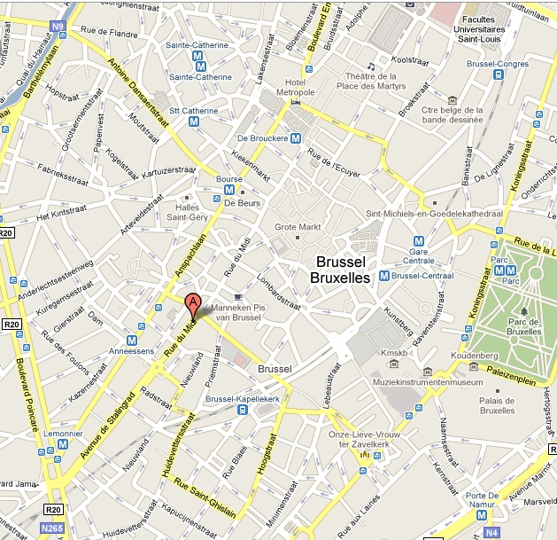
- International Office for Water: conf_IWRMNet@oieau.fr, +33 (0)5 55 11 47 47
- On www.iwrm-net.eu

Venue
Bedford Hotel and Congress Centre, 135-137 Rue du Midi, Brussels

